Suzuran -

Having learned considerably from the ritual you performed on the water shrine, you’ve been refining your knowledge of Fused Rituals. The ritual you performed may have felt slightly anticlimactic at that time, but since then you realize that part of the results were not immediately obvious - or planned. The ritual did something more to the water shrine than merely repair it. You always seem to know the exact direction of that shrine, though you couldn’t say the same about any of the others. You dream of flowing water, and when you touch it to bathe or drink, it feels even better than it used to. The shrine resonates with you now, somehow. It was an easily-dismissed whisper before, but now that you are back in the Waste, you can feel it more strongly. While the intent may have been to repair the water shrine, your ritual did something more - and you can extrapolate the results.

The amulet you used last time is still empowered with energy from each of the 6 shrines. You also need certain physical components: a living thing found at a shrine two points off from the one where the ritual will be performed, and a core, essence, of distillation of some sort from the shrine opposite the one where the ritual will be performed. For the earth shrine, you would need an earth-related living thing from the fire shrine and a core of some sort from the life shrine. For the lightning shrine, you would need an air-related living thing from the water shrine and a core of some sort from the death shrine. While asymmetrical, if two rituals are done in this way, all shrines are used and this seems the most magically balanced and therefore most efficient and powerful.

As before, having at least one individual from each path would be best, though more would be better. In a pinch, just Magic, Nature, and Mind will do, but success is less likely in that case and individuals will be doing double work.

With six shrines and five paths, you must begin the ritual by inscribing a pentagram either inside or overlaying a hexagram, with the hexagram points lined up with the directions of the 6 shrines and each shrine marked with its name in Sah’mat. (You can make up sigils for these, and your newfound direction sense for the water shrine makes orienting easier than it might sound.) The five paths must stand at the five points of the pentagram and declare their roles in the ritual: Steel bolsters, Magic infuses, Faith supports, Nature channels, and Mind guides. Place incense at the outer six points and light it. After each path completes their incantations, you will need to sacrifice the living thing and destroy - smash, pour out, etc. - the core/essence/distillation. At this point, all must call upon the spirit inhabiting the shrine; when it appears, it must either consent to the ritual you are performing or be rendered unconscious/unable to hinder you. When it comes forth, you will understand what type of spirit it is and can ask its name.

Finally, using the concept of Kotodama, you must use the word for the type of spirit (in Sah’mat) and its name along with the Sah’mat words for “unity” (echad) and “selfless servitude” (abodah agape). Repeat these as a mantra six times.

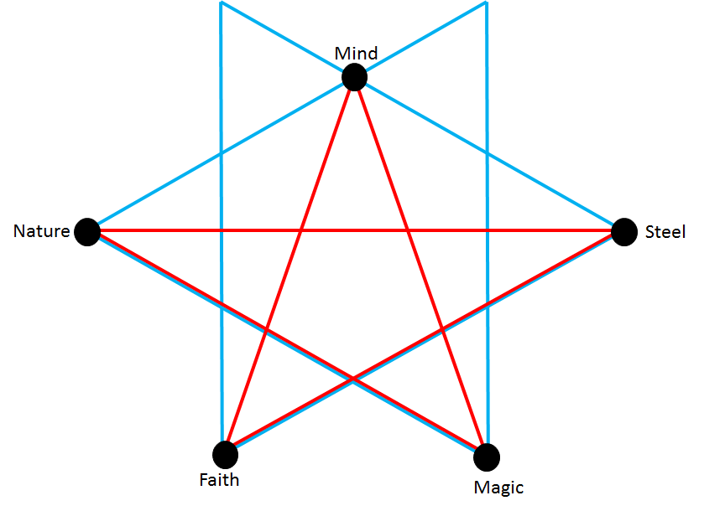

The incantations for each Path:

**Steel**: With our strength and might, we raise this ritual and give it vibrancy.

**Magic**: With our magic and energy, we infuse our power into this space.

**Faith**: With our faith and dedication, we hold this ritual firm and true.

**Nature**: With our wisdom and cunning, we channel energy and power toward our cause.

**Mind**: With our will and purity of thought, we guide the path of power and weave our lights together.